• ***What your class members will need***: Pen or pencil, cup of water

• ***What you (the instructor) will need***: Teacher’s guide, Balance, Wild Orange, Peppermint, PastTense, OnGuard, Mood blends, “Essential Emotions” class handouts

__________________________________________________________

Slide 1:



Welcome! I acknowledge you for being here, and for choosing to learn more about supporting your emotional health.

*\*Give a brief background on why this topic interests you*\*

Slide 2:

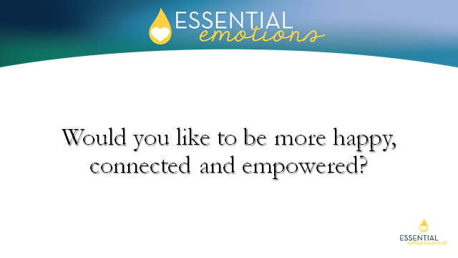

*(Who wouldn’t, right?)*

Slide 3:

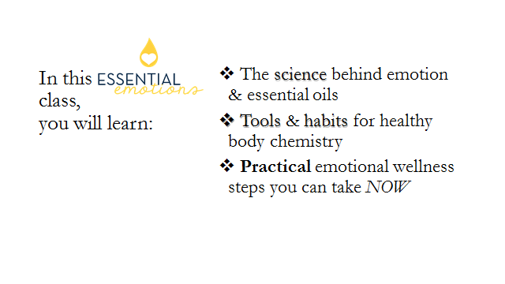

Slide 4:

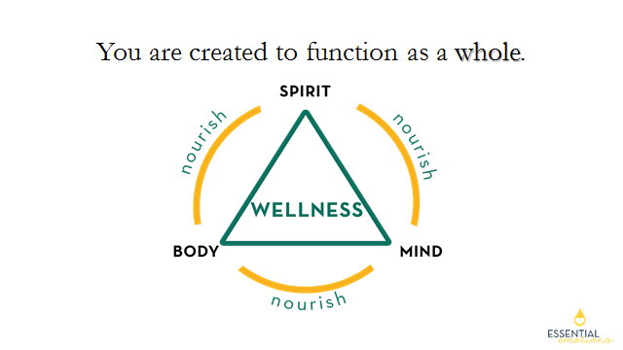

You are created to function as a whole.  The spirit, mind and body are inseparably connected, communicating at a cellular level.

Slide 5:

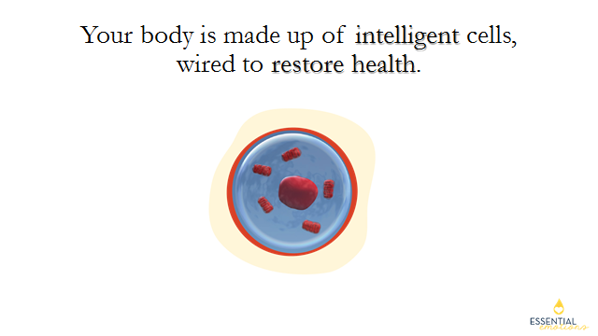

  This means your body is brilliant in design and naturally wants to be balanced and whole.

Slide 6:

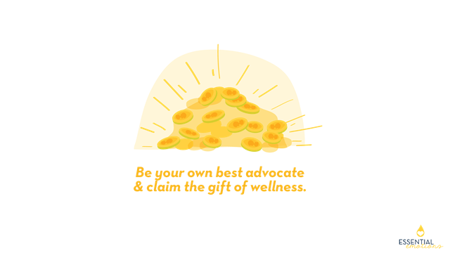

I invite you to learn about your *amazing* body today and listen to what it may be teaching you.  Be your own best advocate and **claim** the gift of wellness!

Slide 7:

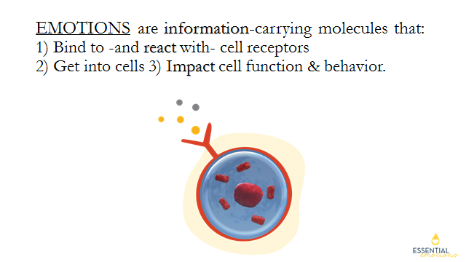

To learn the language of your body, you need to know what emotions are and what they are communicating.

  Emotions are information-carrying molecules that bind to and react with cell receptors.  They go into the cell, impacting function and behavior.

In other words:  Emotions, in their smallest and most basic form, are chemical molecules.  In this image, the cell is receiving these molecules on one of its *receptors*.  Receptors are molecules that function as senses or scanners, much like our eyes and ears.  These receptors gather in a cluster at the surface of a cell, waiting for a chemical to attach a message.  This new information is received inside the cell - impacting your energy level, your behavior, and your mood.  It’s FASCINATING to discover how emotions affect our health!

Slide 8:

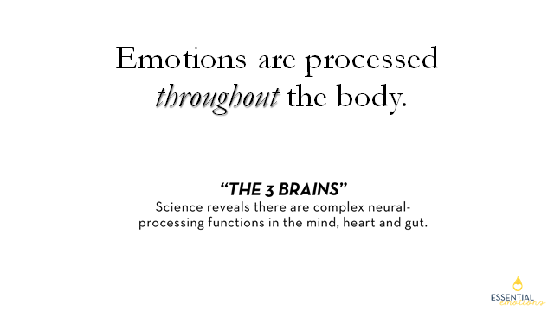

  Because emotions are chemicals, they are not limited to the mind.

Emotions flow and are processed throughout the body.  Science reveals there are complex neural-processing functions in the mind, heart and gut.  These “**3 brains**” are neural networks with independent memory and intelligence.  This means you can actually process feelings in each of these brains.

Slide 9:

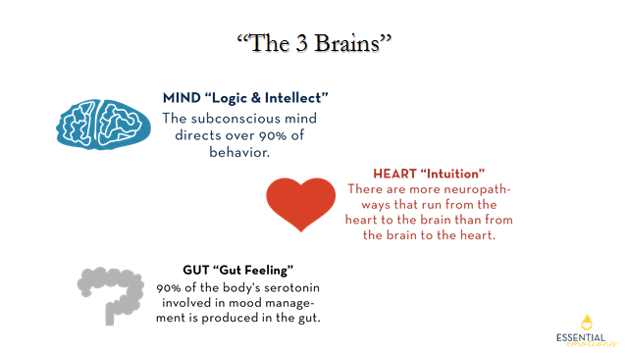

The **mind** is like a conductor, directing the body to feel emotionally and behave physically.  The **heart** discerns the messages our brain receives.  The **gut** responds accordingly, distributing health or illness to the rest of our body.

Slide 10:

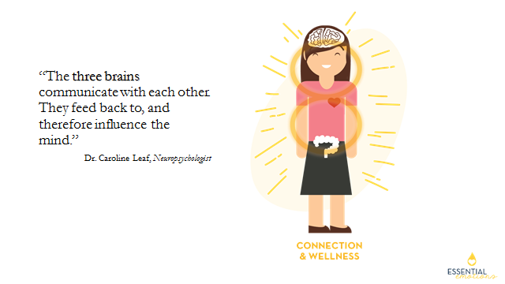

*Isn’t it* ***amazing*** *the power your body holds to choose wellness?*

Slide 11:

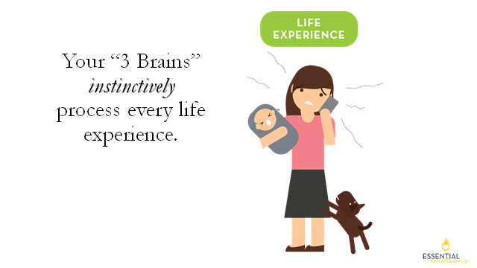

Let me walk you through how this works.

 Have any of you ever felt like the woman in this picture?  This moment is immediately recorded in her subconscious mind.

Slide 12:

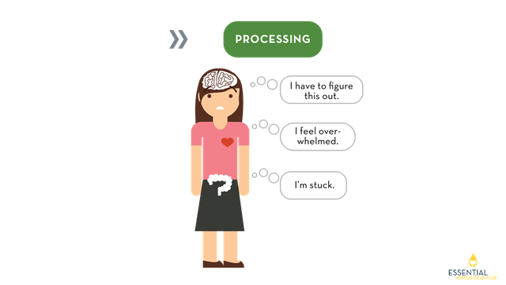

  In this image, you can see how each “brain” sends its own message.  The ***mind***might think, “I have to figure this out” (it’s my responsibility after all, right?) The ***heart*** says, “I feel overwhelmed” (maybe I’m holding too much?)  The***gut***reinforces, “I’m stuck” (I don’t know what to do).

Slide 13:

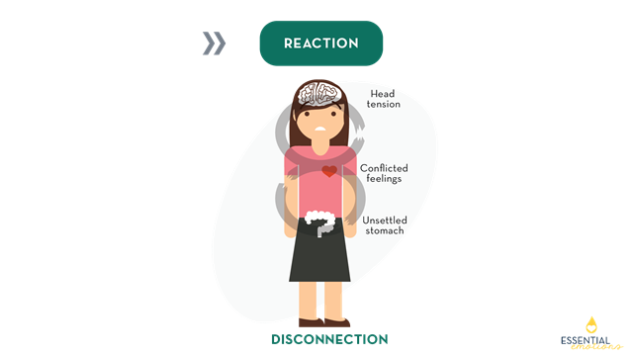

A biochemical reaction then occurs.  One may feel conflicted, confused, even notice an unsettled stomach.  These negative reactions are the consequence of conflicting messages, which disrupt internal balance.  This results in disconnection or “dis-ease.”

Slide 14:

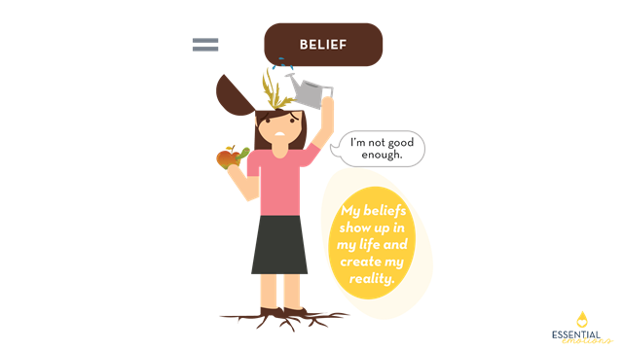

When we think and feel something simultaneously, a **new belief** is created. In this example, she now concludes, “I’m not good enough.”  We are always reinforcing old beliefs or planting new ones.  Nurturing a belief produces “fruit.” Are you cultivating a *seed* or a *weed*?

Slide 15:

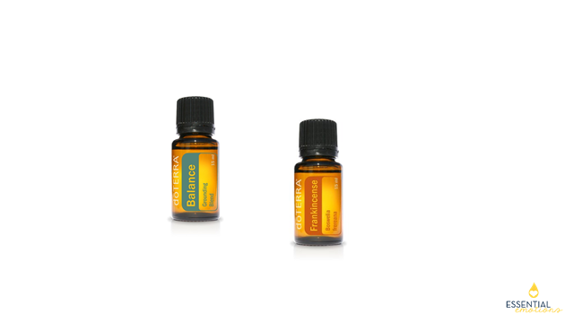

    \**Hold up* ***Balance*** *oil*\*

Essential oils are an incredibly effective emotional wellness tool.  This is a mood blend called **Balance**.  It is calming and grounding to the central nervous system.  It contains **Frankincense**- a powerful cleanser and magnifier that opens the mind’s eye. (\**apply on forehead*) and connects the soul with its authenticity (\**apply on heart*).

\**Pass* ***Balance*** *and* ***Frankincense*** *around the room*\*

Would anyone like to share your experience with Balance or Frankincense?  How have you noticed a difference, emotionally, by using them?

Slide 16:

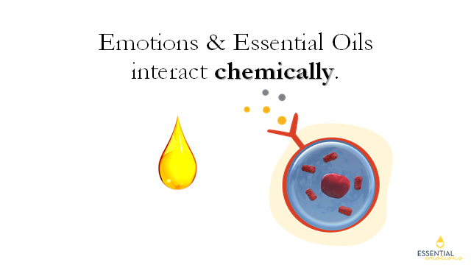

Because both emotions and essential oils are chemically- based, a powerful reaction occurs as they make contact within the body.  Essential oils are very *chemically complex*, which is why each oils is able to have so many uses and applications.

Slide 17:

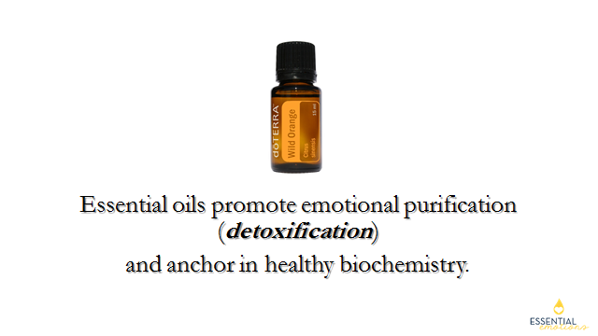

  This means they are efficient at detoxing the cell and restoring proper cell function.  It is amazing how **biocompatible** essential oils are with the body.

\**Hold up* ***Wild Orange*** *oil*\*

I’m going to pass this Wild Orange around.  Take a moment and really inhale its wonderful aroma.  Wild Orange invites connection in the body and stimulates energy.  Many people love to put Wild Orange in the diffuser to diminish feelings of overwhem in their environment.  Citrus oils like Wild Orange are great at uplifting mood and promoting toxic release.

\**Pass* ***Wild Orange*** *around and demonstrate oils dropped in the diffuser*\*

Slide 18:

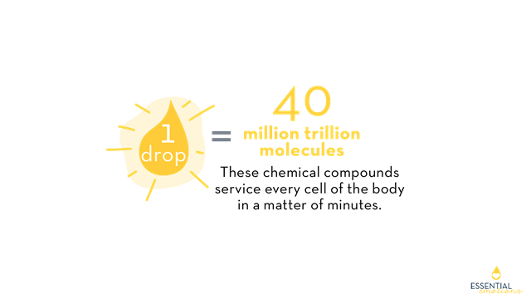

One of the reasons essential oil molecules go cellular so quickly is because they are extremely *molecularly dense*.  One drop of essential oil has 40 million trillion molecules.  Tiny molecules from the chemical compounds in essential oils can service *every* cell of the body within *minutes*.

Slide 19:

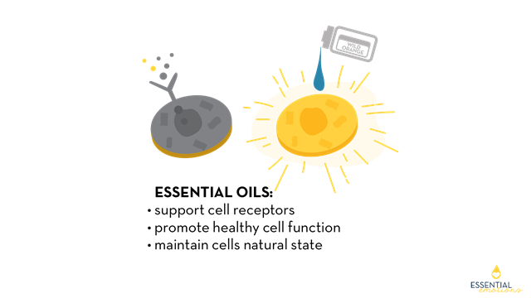

  Because of their chemical complexity, essential oils promote emotional AND physical ***detox***.  They help remove conflicting cellular messages and encourage cellular ***restoration***.

* They support those receptor sites on the surface of our cells - reviving and enhancing them.  ***This is one of the reasons essential oils do not carry side effects!***
* They go into the cell efficiently, after they bind to the receptors on the cell’s surface.  This efficient process enhances cell function.
* Also, essential oils are able to restore and maintain the state a cell is naturally and intelligently designed to embody!

Slide 20:

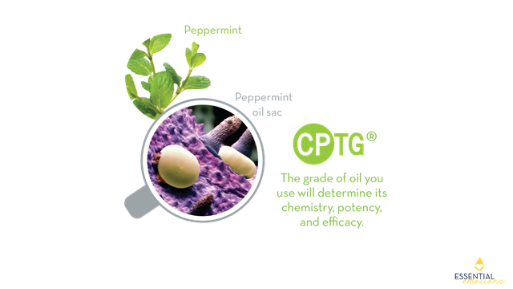

   Here is a picture of a peppermint leaf, and just below it - a magnified peppermint leaf.   These oil sacs sitting on the surface of the peppermint leaf in the magnified photo are the volatile life-force of the plant.  Essential oils course through the plant as its “life blood” - helping the plant defend, nourish, and repair itself.   Essential oils have the same function in the plant as blood has to the human body.

  The quality and grade of an essential oil will determine its effectiveness. Certified Pure Therapeutic Grade oils are the safest, purest oils to use for supporting the physical and emotional needs of your body. The chemical compounds in CPTG oils are friendly to the body’s natural biochemistry.

Slide 21:

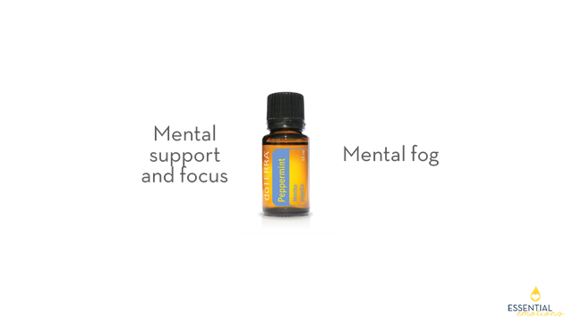

  \**Hold up* ***Peppermint*** *oil*\*

This is Peppermint, one of doTERRA’s most popular oils.  Physically, Peppermint is energizing, oxygenating and supports brain focus.  Emotionally, Peppermint invigorates and dispels mental fog.  Either way, Peppermint “PEPS” you up!

\**Pour a drop in your hand, rub your hands together, cup and inhale*\*

Let’s pass this around so you can experience Peppermint aromatically, being careful not to get into your eyes!  Peppermint is very intense and powerful.

                                    \**Pass* ***Peppermint*** *around*\*

Slide 22:

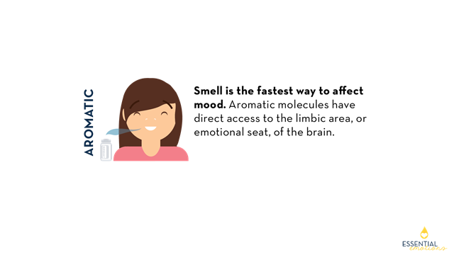

There are 3 ways to experience essential oils and the first is **AROMATICALLY**.  There is a reason this process is called “*aroma****therapy***.”  Smell is the fastest way to affect mood and the quickest way to get into the deepest parts of the mind-brain.  Our sense of smell is more complex than any of our other senses, including sight.  There are smell receptors on EVERY organ of the body!  As you inhale an essential oil, those aromatic molecules travel to the olfactory bulbs, which are linked directly to the emotional (limbic) seat of the brain.   This is how inhalation creates an *immediate* emotional impact.

Slide 23:

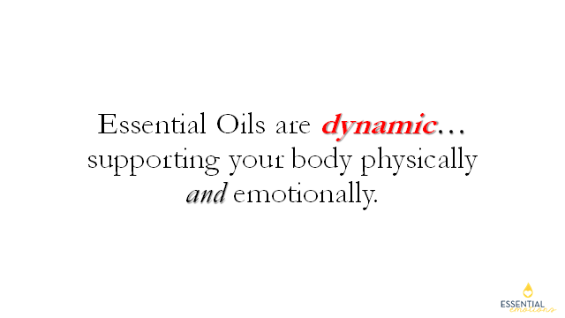

  Essential oils are DYNAMIC - shifting and changing intelligently as they interact with your body’s biochemistry.  **You will discover that each and every essential oil has both physical and emotional components and applications.**  Again, this is because of their chemical complexity.

Slide 24:

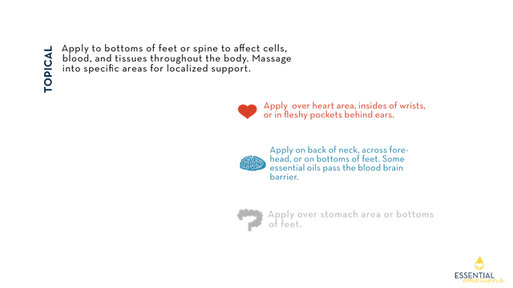

  The second way we can use essential oils for emotional support is by applying them **TOPICALLY**.  Essential oils are ***transdermal***.  This means their tiny molecules can pass through your skin and go straight into your circulatory system.   Applied anywhere on the body, essential oils will penetrate every cell.

Here are some great tips for TOPICAL application, to affect the “3 brains” of the body.  **Wherever you are holding occasional tension, you can massage an oil into that area for localized support**.

\**Share a few of your favorite applications*\*

Slide 25:

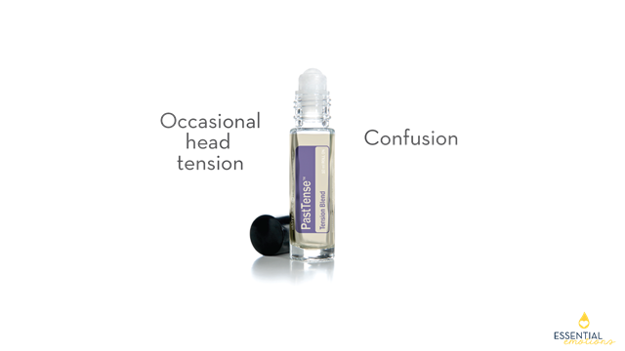

     \**Hold up* ***PastTense*** *oil*\*

**PastTense** is a great topical blend.  Physically - it can be applied for occasional head tension.  Emotionally - it can be used for occasional emotional tension and confusion. Apply some over the back of the neck, on the temples and/or along the forehead.

\**Pass around* ***PastTense****\**

Slide 26:

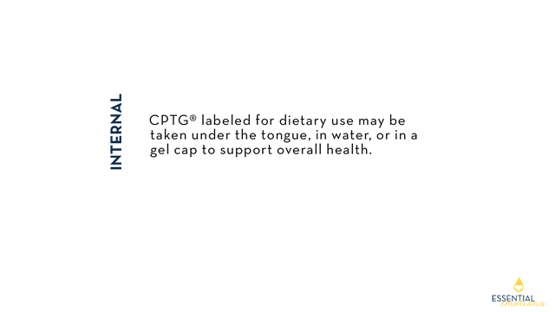

The third way we use essential oils is exclusive to CPTG oils:  **INTERNALLY**.  CPTG oils labeled for dietary use may be taken internally in these ways... in water, under the tongue, or in a gel capsule to support overall health.

Slide 27:

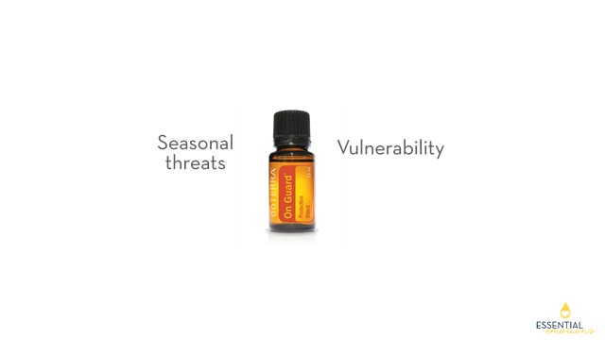

  \**Hold up* ***OnGuard*** *oil*\*

**OnGuard** is a protective blend.  Physically, it protects the body against seasonal threats.  Emotionally, it protects against environmental threats and promotes emotional boundaries.  It can protect against feelings of vulnerability.

\**Demonstrate licking a drop from the back of the hand. Then, pass around* ***OnGuard***\*

The essential oils we’ve highlighted are only a small sampling of the power essential oils have for maintaining physical and emotional well being.  All of doTERRA’s 100+ essential oils and blends have emotional and physical benefits.

Slide 28:

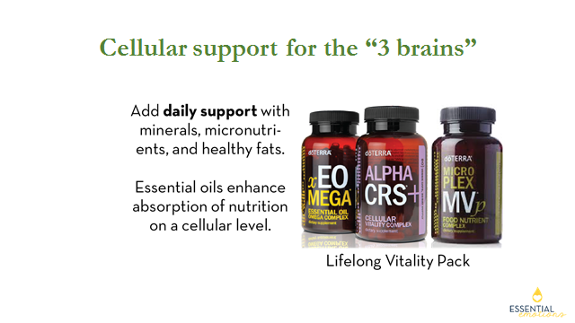

As we discussed earlier, gut, brain and heart health are interconnected. Essential oils are most effective when combined with good nutrition, digestive health, and proper circulation.

*\*Hold up the* ***LLV box****\**

  The Lifelong Vitality Pack (LLV) is a daily supplement trio that lays a strong foundation for physical and emotional health.  It provides an excellent source of minerals, micronutrients and healthy fats.

**Together, these 3 supplements provide our “3 brains” the daily cellular support they need for us to FEEL GOOD, emotionally and physically**:

\**Hold up individual bottles as you talk about each\**

**xEO MEGA** provides 9 essential oils and omega fatty acids to the “3 brains”...supporting brain nourishment, heart and circulatory health, and digestive functioning.

**Alpha CRS+** contains potent antioxidants that promote chemical communication in cellular pathways.

**Microplex MVp** is your vitamin and mineral supplement.  It provides optimal levels of micronutrients for immune function and energy.

Slide 29:

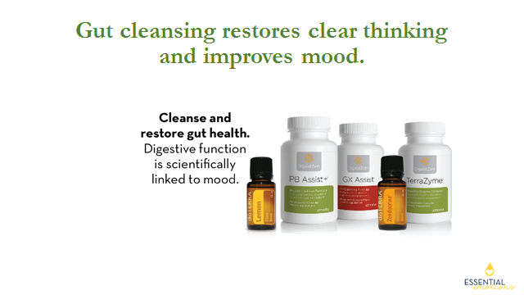

Regular cleansing of the gut restores healthy physical function...but is also necessary for clear thinking and mood management.  **Low digestive function has been scientifically linked with low mood.**  Remember, 90% of your body’s serotonin is produced in the gut!

**PB Assist** contains pre and probiotics that help to sustain healthy colonies of microflora and good bacteria in the gut.  This helps to foster:

* nutrient uptake
* energy metabolism and
* GI immunity.

**TerraZyme** is a digestive enzyme complex that supports:

* conversion of food to cellular energy and
* healthy production of metabolic enzymes.

**GX Assist** provides a natural but powerful cleanse of the GI tract.

**Lemon** oil and **Zendocrine Detoxification Blend** help support the body’s natural ability to cleanse itself.

Slide 30:

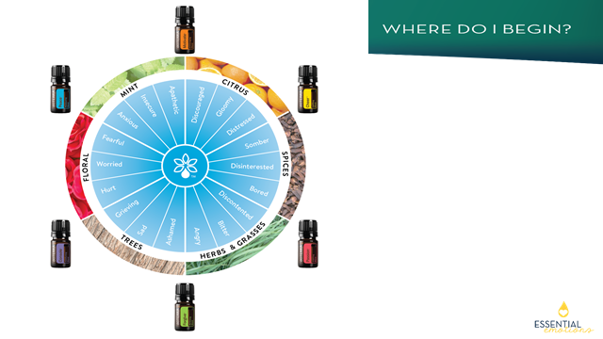

That is a lot of information, is it not?  Let’s just take a breath for one moment and simplify!

You might be asking, **Where do I begin**?   Change is a gift that is always available to us.  If you are ready to feel better and experience more out of life, you are in the right place!

  dõTERRA has just introduced 6 new mood blends, making a total of 10 blends specifically designed for mood!  Featured here is the new ‘**Aromatherapy Wheel**’- a great tool to help support your mood in any given moment.

Notice how there are 6 different types of plants that produce an essential oil to give support in their own, unique and specific way.   How they grow is a lot like how they react in our bodies.  Take, for example, **Citrus oils**.  Citrus plants grow in warm, sunny climates; elevated high off the ground.   Citrus oils are uplifing, elevating, happy oils!  Another example are **Tree oils**.  Trees are rooted deep into the earth, offering a strong foundation for the plant to have strength and stability.  Tree oils offer us the same properties - they help us to feel more balanced, grounded, and secure.

So let’s put this ***Aromatherapy Wheel*** to work.  Identify what you are feeling NOW, in this particular moment.  Maybe you are feeling more than one thing.  What speaks loudest to you?  Then, choose one or two oils that best fits.  For example, if I am experiencing anger or bitterness and have agitated feelings,  I might want to try ***Forgive*** to feel more calm and collected.   I would place *Forgive* over my heart,  on the insides of my wrists or across my forehead to help.  Ok, let’s say I have just lost a loved one and am in the grieving process.  Which oil would best suit my needs? ….  That’s right, ***Console*** would be an excellent choice to offer that kind of support.  Again, I would place a drop or 2 over my heart, on my forehead or temples, and on the insides of my wrists.

*\*Demonstrate on heart, forehead, wrists\**

Slide 31:

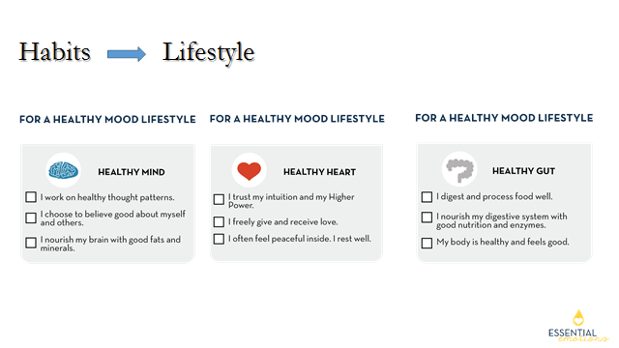

  Becoming happy, connected and empowered requires choosing healthy habits.  Healthy mood habits create a healthy mood lifestyle.

  As a first step, it’s helpful to understand where you are now.  This is a quick assessment to help you understand how connected your brain, heart and gut really are.  For each “brain,” simply put a checkmark next to the statements that seem true for you.  Let’s take a moment and do that now.

*\*Give your class one minute to checkmark the “3 Brains” boxes\**

The statements you have checkmarked are areas of strength--areas to celebrate and continue to nurture.  The statements without check marks may reflect healing gestures and opportunities for growth.

Slide 32:

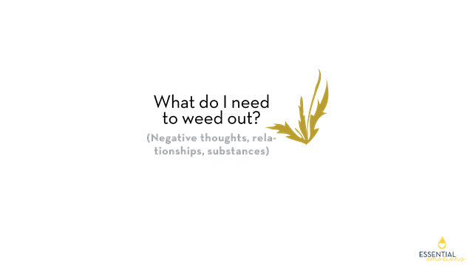

   Based on what you discovered, what is one “weed” you want to remove?  It might be a negative thought, relationship or substance.  For instance, I may have the thought pattern, “I’m overwhelmed.  I feel stressed.”

*\*Invite them to look at the Aromatherapy Wheel for clues as to some of their "weeds"\**

Slide 33:

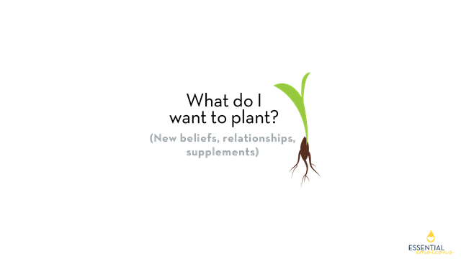

  What do I want to plant instead?  It could be a new belief, relationship or supplement.  For example, I may want to plant the new belief, “I am completely supported in every moment.”

*\*Invite them to look at the* ***Aromatherapy Wheel*** *to identify desired emotions.  These may be the opposite of the negative emotions.\**

Slide 34:

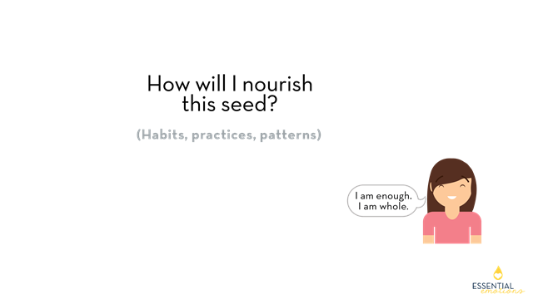

How will I nourish this seed?  “Nourishment” includes habits, practices and patterns. (Personally, I like to smell Wild Orange as I anchor in my new, positive belief.).  You will also notice some tips below if you need some inspiration.  As I am consistent, the fruit of my new belief is: “**I am enough, I am whole**.”

Slide 35:

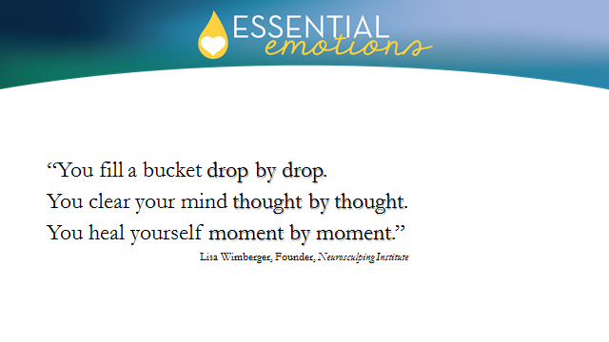

  As you claim greater wellness, remember: “*You fill a bucket drop by drop.  You clear your mind thought by thought.  You heal yourself moment by moment*.” Small and simple changes can yield great results!

In this class, we have discussed practical emotional wellness steps you can take NOW.   It’s exciting and rewarding for me to offer the “gift of change” to others.  I invite you to let me be your guide in starting your new habits and I ask, **“Are you *ready* to begin creating new habits today?  Are you ready to claim the gift of wellness**?”

As you’ve sat through this class, you may have asked yourself, “Which tools will I use to nurture my healthy body chemistry?”  One of my favorite parts about doing what I do is helping others get these beautiful emotional wellness tools into their homes….so they can begin using them day by day, moment by moment.

Slide 36:

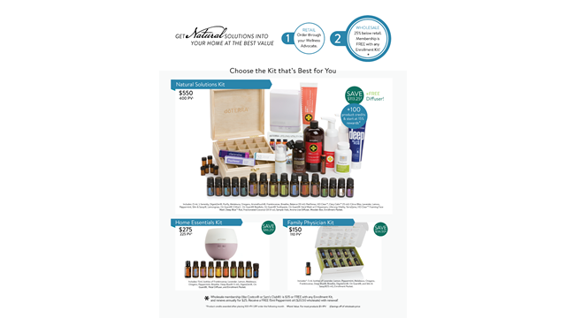

  Here is how it works.  You can either order doTERRA products RETAIL, through the Wellness Advocate who invited you to this class.  Or…dõTERRA offers people the ability to get products wholesale by becoming a “WELLNESS ADVOCATE.”   **As we shared in the beginning, YOU are your own best advocate**!   Wellness Advocates are over 2 million strong and counting.

Become a Wellness Advocate and get 25% off retail.  Simply pay a $35 membership fee and receive any of dõTERRA’s products at wholesale for a full year.  At the end of every year, you renew this wholesale membership for $25... and receive a free Peppermint oil….\**hold up Peppermint oil*\*

As you will see here, dõTERRA offers a number of different starter KITS. Most people enroll with a KIT because:

* The $35 membership fee is waived
* You receive free product credits
* You get bonuses to your membership

  Take a look at these KITS.  Our most popular, best-selling kit is the **Natural Solutions Kit**, shown right there at the top.  It includes a free diffuser and most of the oils and supplements we’ve talked about today, including precious ***Frankincense***.  You will notice it includes the Lifelong Vitality Pack and other spa and wellness products we didn’t have time to cover.  Many people start with this kit because it addresses **physical and emotional needs so thoroughly** and is an amazing value!

Slide 37:

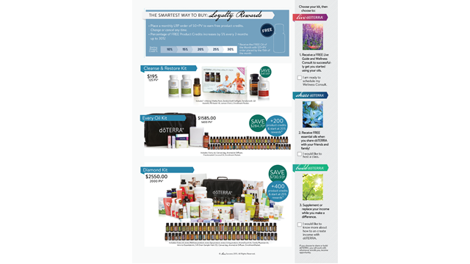

  dõTERRA rewards its members very generously with freebies and promotions.   Most Wellness Advocates choose to use their membership by taking advantage of the **Loyalty Rewards Program** (LRP).

LRP is similar to a Costco or Sam’s Club wholesale membership, but *better*. It is like being in a “monthly wellness club” - with wonderful perks.   As long as you keep your “LRP” at 50 PV, which is about $50 per month, you will keep earning free product.

The percentage of free product credit starts at 10% and increases by 5% every few months. After a year, you receive a full **30%**  in product credit that can be used as CASH!  You are already getting 25% off retail, and by the end of one year, another 30% in kick-backs.  LRP is the smartest way to buy dõTERRA’s products but is totally optional.  LRP is very flexible...You can stop and/or start it up again any time. And...dõTERRA gives shipping credits - or reimbursed shipping - on LRP orders!

**\*I love utilizing the Loyalty Rewards Program because I take the LIfelong Vitality Pack *every month* to nourish those “3 brains” we’ve been talking about**.  I have worked the LLV cost into my food budget because I know that many foods are lacking in minerals and good fats.  Since I need these supplements every month, I may as well receive product credits for purchasing them. I enjoy getting hundreds of dollars in free product every year through my LRP points!

*\*or...share a quick personal testimonial of another consumable dõTERRA product you receive monthly through LRP\**

  You can see next to each kit’s picture that each KIT starts you at a different LRP percentage.  The larger kits, like this Diamond Kit, start you out at the 25% product credit level...AND you also receive more free product with the larger kits.

Slide 38:

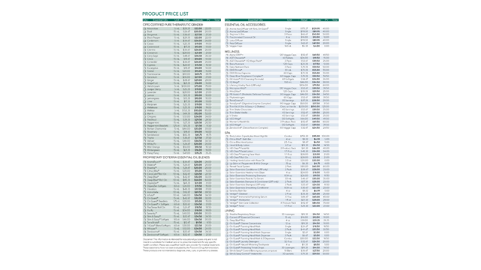

  This is a **Product Price List** that includes doTERRA’s full product line.

Occasionally, a person will design their own enrollment kit by purchasing individual items and paying the $35 membership fee.  They can pick and choose which oils and supplements to start with.  However, they are not able to get the free product that the KITS offer.

You will see here that in addition to the oils and supplements, doTERRA has:

* cleaning and household products
* spa products
* weight management products

...and more

Slide 39:

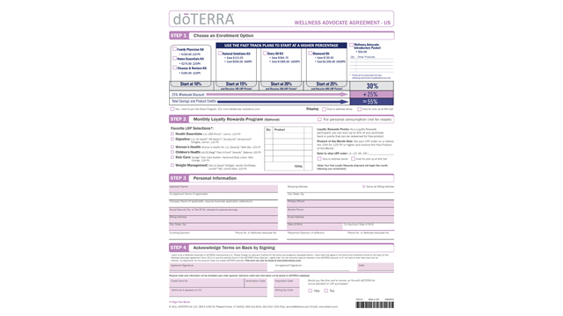

  I would love to walk around and speak personally to as many of you as I can.  We can figure out together which kit best meets you and your family’s physical and emotional needs.

When you become a Wellness Advocate, you become part of our organization --- and ***we take care of you!***We help you get to the bottom of your health concerns and create a wellness plan.  doTERRA as a company - and as a culture - also offers free education and support to help you learn to live life to its fullest!

1.  **Step 1** of this WA Agreement is where you choose your kit.

2. **Step 2** gives you the option of choosing your LRP for next month.  You can look on the Product Price List on the previous page to see all doTERRA’s products.

3.  **On Step 3**, fill in your Personal Information.  **Get with the person who invited you to this class so they can help you fill out the section on “enrolling sponsor” and “placement sponsor.”**

4. **Step 4** is where you enter your credit card and sign your WA agreement to receive your wholesale membership account

5.  Don’t forget to also sign the bottom of the last page, under **Terms and Conditions**.

Slide 40:



Once again, I want to acknowledge you for showing up today to learn about maintaining your emotional health.  Please remember that YOU are own *your own* best advocate and that wellness is a gift that you CAN claim!

I look forward to getting to know each of you better and having you part of our organization!  Thank you!